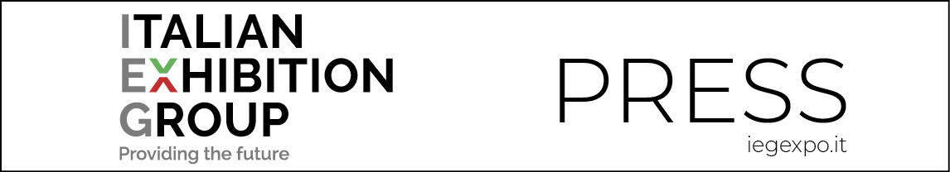

Press Release
(English translation)

IEG FILLS THE EXPO CENTRE WITH ITS TOURISM, SUSTAINABILITY & DESIGN EXPOS

- At Rimini Expo Centre from Wednesday 12th to Friday 14th October, Italian Exhibition Group is organizing no less than 5 expos simultaneously

- The entire world of tourism with: TTG Travel Experience, Sia Hospitality Design and SUN Beach&Outdoor style; of mobility with IBE Intermobility and Bus Expo and of innovative and sustainable surfaces with Superfaces.

Rimini, 10 October 2022 – It will be a house-full Rimini Expo Centre, which will simultaneously host no less than 5 expos by Italian Exhibition Group, from Wednesday 12th to Friday 14th October.
In fact, as well as the entire “no constraints” tourism world, with the 59th edition of TTG Travel Experience, the 71st of SIA Hospitality Design and the 40th SUN Beach&Outdoor Style, doors will open on the 10th IBE Intermobility and Bus Expo, addressing the future of sustainable mobility, and Superfaces, the first Italian marketplace dedicated to all types of surfaces and materials for architecture.

Tourism and sustainability are two of the keywords of three eagerly awaited days to update on one of the driving sectors of our economy. Trade members at the expos will discover the new trends and most fascinating destinations, as well as the new products and services of the entire product chain, through to the mobility of the future and innovations on the topic of architecture. Three days which confirm that Rimini Expo Centre is the reference international marketplace. Here, in a few words, is what each single expo offers:

TTG Travel Experience: the most important event for Italian tourism products and for presenting international destinations to the market. “Unbound” is this edition’s key word: tourism wants to free itself from restrictions, market stereotypes and conventions, to open up to the unexpected. The foreign destinations proposed are truly countless: from Jordan – this edition’s partner country – to Saudi Arabia, Japan to Bahamas, Egypt to Andalusia, to mention just a few.

SIA Hospitality Design: the world of camping, glamping and outdoor tourism in direct contact with the hotel hospitality sector. In fact, this edition’s new feature is the open-air chain, increasingly close to the hotel industry world, thanks to the recent agreement inked by IEG and FAITA Federcamping.

SUN Beach&Outdoor Style: confirms its role as the leading expo in Italy for seaside tourism. The Beach Village area will feature all the new trends for vacations on the beach, while the Innovation Seastyle Area will propose all the innovative solutions of products and services.

IBE Intermobility and Bus Expo: the biennial expo dedicated to the world of mobility, with particular attention focussed on the issues of the sector’s sustainability and ecological transition. This edition’s agenda is particularly busy, with numerous events by the Technical Scientific Committee.

Superfaces: the first Italian b2b marketplace dedicated to all types of surfaces and material for architecture, interior and design continues its cooperation with SIA Hospitality Design, strengthening the entire chain, from designers to end users.

FOCUS ON ITALIAN EXHIBITION GROUP
Italian Exhibition Group S.p.A., a joint stock company listed on Euronext Milan, a regulated market organised and managed by Borsa Italiana S.p.A., has, with its facilities in Rimini and Vicenza, achieved national leadership over the years in the organisation of trade shows and conferences. The development of activities abroad - also through joint-ventures with global or local organisers, in the United States, United Arab Emirates, China, Mexico, Brazil and India, for example - now sees the company positioned among the top European operators in the sector.

This press release contains forecast elements and estimates that reflect the management’s current opinions (“forward-looking statements”), particularly regarding future management performance, realization of investments, cash flow trends and the evolution of the financial structure. For their very nature, forward-looking statements have a component of risk and uncertainty, as they depend on the occurrence of future events. The effective results may differ (even significantly) from those announced, due to numerous factors, including, only by way of example: food service market and tourist flow trends in Italy, gold and jewellery market trends, green economy market trends; the evolution of raw material prices; general macroeconomic conditions; geopolitical factors and evolutions in the legislative framework. Moreover, the information contained in this release does not claim to be complete, and has not been verified by independent third parties. Forecasts, estimates and objectives contained herein are based on the information available to the Company as at the date of this release.

